Name __________________________________

Ocean Reef Senior High School
Year 11 ATAR Psychology
Assessment Task 5 – In-class Test 2
55 marks (5% Response)
OUTCOMES:
Outcome 1: | Psychological understandings
Outcome 3: | Applying and relating psychological understandings
Outcome 4: | Communication in psychology

ALLOCATED TIME FOR THE TASK:
- You will have one period to complete the test in class.

INSTRUCTIONS:
- Attempt all questions
- Complete under test conditions (no notes, files etc. to be accessed)
- Ensure mobiles phones are switched off and are not on your person

Section One – Multiple Choice
Total | / 24

Section Two – Short Answer
Question 1 – Biological Influences | / 6
Question 2 – Cognition | / 25
Total | / 31

Total Marks
Section 1 | / 24
Section 2 | / 31
Assessment Task 4 – Total Marks | / 55 ( %)

Teacher comment: _______________________________________________________________________
______________________________________________________________________________________
______________________________________________________________________________________
______________________________________________________________________________________
______________________________________________________________________________________
Section One- Multiple Choice Questions
24 Questions – 24 marks

- Prolonged use of ecstasy leads to:

- reduced production of dopamine
- reduced production of serotonin
- reduced production of endorphins
- all of the above

- Which of the following was NOT a finding of Field and her colleagues (2001) study into the positive effects of high levels of exercise on American high school students:

- students were less depressed than their peers
- students achieved better academic grades
- students reported better relationships with their peers
- students engaged in less drug use

- The finding that aerobic exercise is an effective treatment for mildly depressed female college students was found by:

- Myers (2004)
- Statistics Canada (1999)
- McCann & Holmes (1984)
- Field and colleagues (2001)

- The state of consciousness is:

- An awareness of the existence of ourselves and of objects and events in the external world
- A state of mind where you only daydream and meditate
- Not continuous, selective or changing
- A state of mind where you focus on what you have selected to, virtually oblivious to other things going on around you.

- Using an electroencephalogram (EEG) to gauge a person’s level of consciousness is an example of a:

- subjective quantitative measure
- subjective qualitative measure
- objective quantitative measure
- objective qualitative measure

- Which of the following is NOT usually associated with an altered state of consciousness (ASC)?

- inaccurate recollection of memories
- reduced levels of suggestibility
- distorted sense of time
- out of body experiences

- States of consciousness are measured through physiological responses. Which of the following is NOT a physiological measurement of a person’s state of consciousness:

- brain waves
- body temperature
- reported level of awareness
- heart rate

- Habituation occurs when:

- a change in the stimulation is so intense it causes us to pay attention
- predictable and unchanging stimuli fail to command attention
- mental effort must be divided between tasks or stimuli
- we consciously give priority to some stimuli over others

- _________________ involves our sense organs receiving physical stimuli such as sound waves and light.

- reception
- recognition
- sensation
- perception

- Visual illusions such as the Poggendorff illusion are useful to psychologists because they:

- can be used to inform a person’s level of awareness
- outline how humans make sense of their sensory environment
- are used in hypnosis and other states of consciousness
- teach us from experience not to trust our senses

- The first person to talk about the notion of general intelligence was:

- Binet
- Wechsler
- Galton
- Goleman

- Charles Spearman proposed a _______ factor theory of intelligence

- one
- two
- three
- four

- Who developed the concept of mental age?

- Francis Galton
- Alfred Binet
- David Wechsler
- Lewis Terman

- If Jane's intelligence quotient is 100, we know that she has a:

- perfect score on a set of age-related tests
- test performance superior to 90% of other children the same age who took the test
- mental age typical of children who have the same chronological age
- mental age below those of children with the same chronological age

- Billy has a mental age of 8 and a chronological age of 10. Billy's IQ is:

- 108
- 125
- 80
- 92

- Which of the following is part of Wechsler's definition of intelligence?

- naturalistic intelligence
- iconic memory and eidetic imagery
- ability to deal effectively with the environment
- spatial and kinaesthetic abilities

- Emotional intelligence involves having

- self-control
- self-awareness
- self-management
- all of the above

- A school curriculum built on Howard Gardner's theory of intelligence would provide:

- neuromuscular training because such skills underlie general intelligence
- training in logic, rhetoric, philosophy and math to strengthen the general factor in intelligence
- emphasis on creative, artistic abilities rather than the traditional emphasis on cognitive abilities
- a diverse curriculum with education in skills not traditionally associated with IQ

- Kinaesthetic learners learn best

- by doing
- by hearing
- by using texts and watching videos
- in calm quiet surroundings

- A small social group that shares activities, behaviours, values, and appearance is considered a:

- family
- clique
- subculture
- crowd

- Prosocial behaviours include:

- helping others
- sharing with others
- making sacrifices
- all of the above

- Bullying in schools is seen when:

- all the students are boys
- all the students are girls
- there is aggressive behaviour designed to harm others
- teachers are unhappy

- The social and cultural differences between young people and older adults is

sometimes referred to as the _________________________________.

- generation gap
- generation stage
- generational divide
- generational difference

- This diagram shows the changing structure of adolescent groups (Dunphy, 1963). Looking at the diagram, which stage reflects the start of dating?

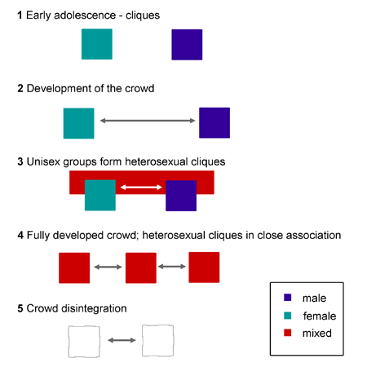
- stage 1
- stage 2
- stage 3
- stage 4

Section Two- Short Answer Questions
Two Questions – 31 Marks

Question One –
Intelligence Questions
Mix and match and name of theorist –
(3marks)

Sensation and perception difference between – (2 marks)

Compare the processed of

Questions Two -
STATE THETY ARE FRIENDS Abdul and Anouk are first years at the University of New South Wales, Abdul came from Melbourne while Anouk grew up in Sydney. Abdul is studying Biomedicine whereas Anouk is studying Pharmacology, they have 4 yearlong modules together and attend the same lectures. Abdul and Anouk often study together, sharing notes and quizzing each other on the content.

Are Anouk and Abdul friends, using terminology related to the Determinants of liking to explain your answer.

Proximity, Similarity and Reciprocity

Question on Communication Q
Question Three – Cognition (25 marks)

- With reference to the brain wave diagram complete the table below. (8 marks)
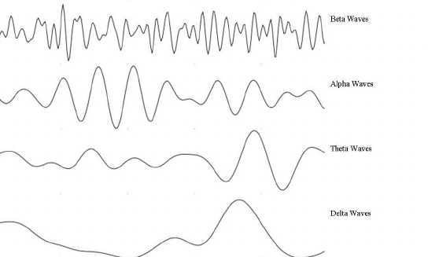

Brain Wave | Name | Frequency (per second) and amplitude of waves | State of consciousness of the person
1 | Beta
2 | Alpha
3 | Theta
4 | Delta

- What is a limitation of using observation to measure a person’s state of consciousness? (2 marks)

______________________________________________________________________________
______________________________________________________________________________
______________________________________________________________________________
______________________________________________________________________________
______________________________________________________________________________
______________________________________________________________________________

- Steven is preparing to complete a timed IQ test. He is feeling alert and slightly anxious before the start of the test, however as soon as the test starts he feels calm and confident. Steven concentrates solidly and without a break for the entire hour-duration of the test. Immediately after completing the IQ test Steven, feeling slightly tired and fatigued at his efforts, sits and daydreams for a short period.

Explain the changes in each of the measures of states of consciousness below that Steven would have experienced from before the IQ test began, through to his daydreaming at the end.
(8 marks)

- Body temperature: __________________________________________________________
____________________________________________________________________________________________________________________________________________________________________________________________________________________________________________________________________________________________________

- Brain waves: ______________________________________________________________
____________________________________________________________________________________________________________________________________________________________________________________________________________________________________________________________________________________________________

- Galvanic skin response: _____________________________________________________
____________________________________________________________________________________________________________________________________________________________________________________________________________________________________________________________________________________________________

- Heart rate: ________________________________________________________________
____________________________________________________________________________________________________________________________________________________________________________________________________________________________________________________________________________________________________

Psychology Multiple Choice Answer Sheet

Name: ___________________________

Please use CAPITAL LETTERS for your answers
Question | Answer
1
2
3
4
5
6
7
8
9
10
11
12
13
14
15
16
17
18
19
20
21
22
23
24

Total / 24: ____________

